Student Name: Fong Ming To

Student Number: 19220456

**The event log from IntelliJ that shows your source code has been successfully built.**

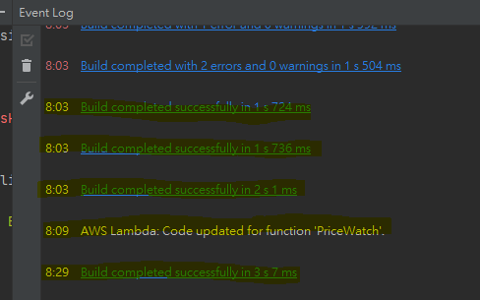

**The AWS Explorer of S3 and Lambda that shows the applications.**

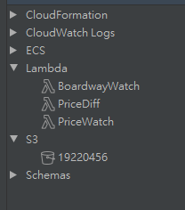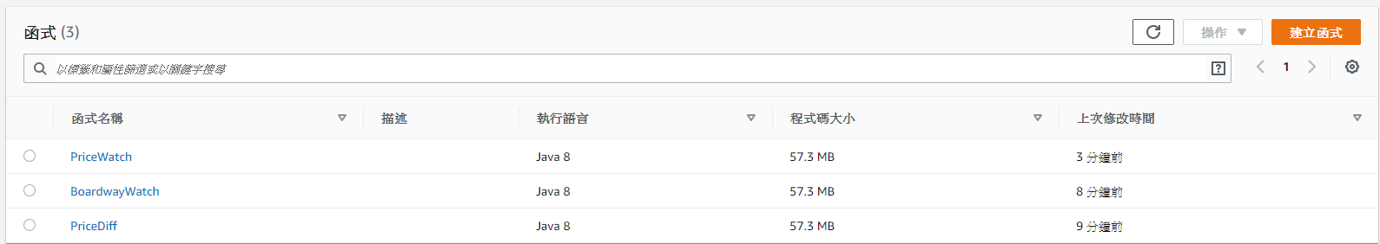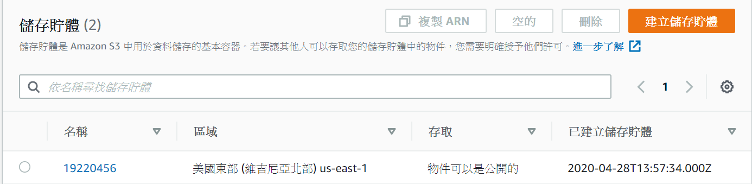

**The output of the applications.**

Task 1. 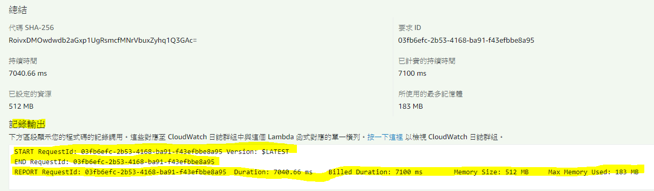

Task 2.

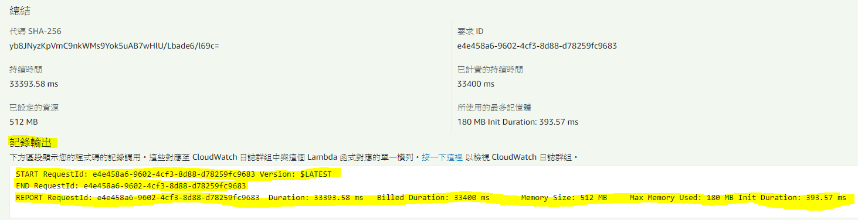

Task 3. 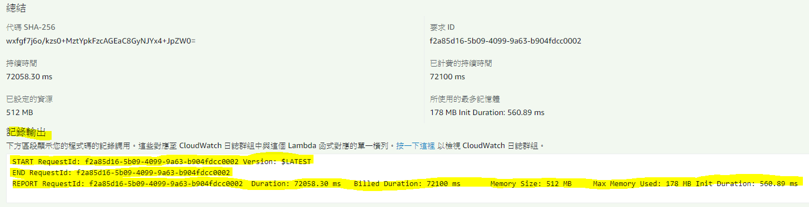

**The schedules of the applications**

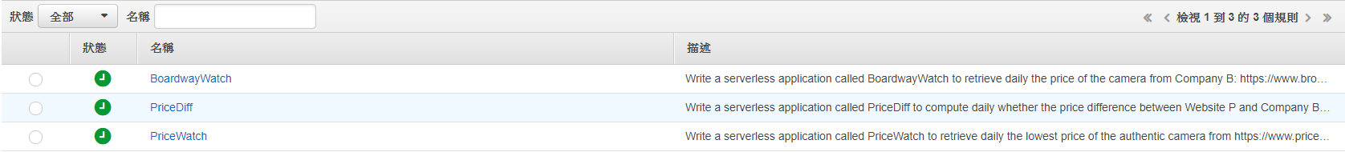

**Any other document/printouts that help to clarify your work.**

Task 1.

Endpoint link: <https://8icugrc19g.execute-api.us-east-1.amazonaws.com/default/PriceWatch>



Successful result: 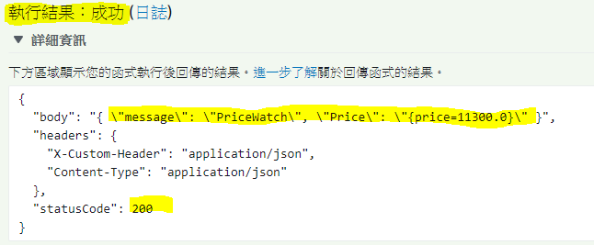

Task 2.

Endpoint link: <https://y4qmuk6uye.execute-api.us-east-1.amazonaws.com/default/BoardwayWatch>

Successful result: 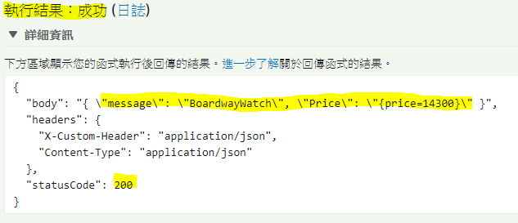

Task 3.

Endpoint link: <https://a0mjxvq8qd.execute-api.us-east-1.amazonaws.com/default/PriceDiff>



Successful result: 